**2019 CAFS Annual Banquet**

**Time:**

Monday June 3, 2019 at 6 -9 pm

**Location:**

Panda King

925 Behrman Hwy, Terrytown, LA 70056

<http://www.pandakinggretna.com/>

**Banquet Admission Fee a:**

**Advanced payment via PayPal to skip the line at the banquet admission and enjoy a $5 discount from regular admission.**

|  |  |
| --- | --- |
| Banquet Admission and Membership Renewal | Price (Advance Payment Discount Applied) |
| Banquet Admission + Pro Membership Renewal | $50 ($30 banquet + $20 membership) |
| Banquet Admission Only b | $30 |
| Non-Member | $40 |
| Student Banquet Admission + Student Membership Renewal c | $30 ($20 banquet + $10 membership) |
| Student Banquet Admission Only b, c | $20 |
| Student Non-Member c | $30 |

a. Advanced Payment: **Please include ‘CAFS 2019 Annual Banquet’ and your name in the PayPal transaction notes. Please print transaction confirmation and bring it to the Banquet.**

b. Proof of active membership or lifetime membership required at the banquet admission on June 3rd, 2019

c. Active student status required. Proof may be requested at the banquet admission.

**PayPal Instruction**

1. Log in to your PayPal account

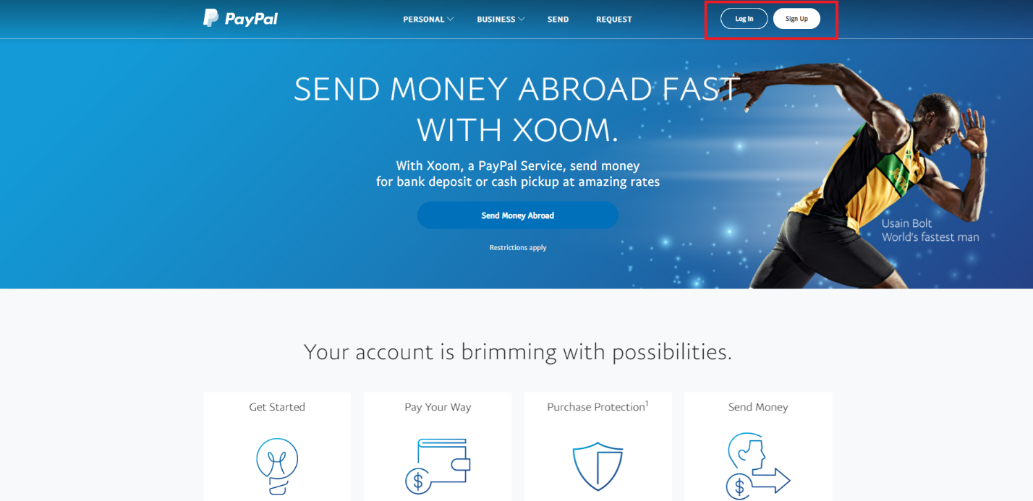

1. Click ‘Send & Request’

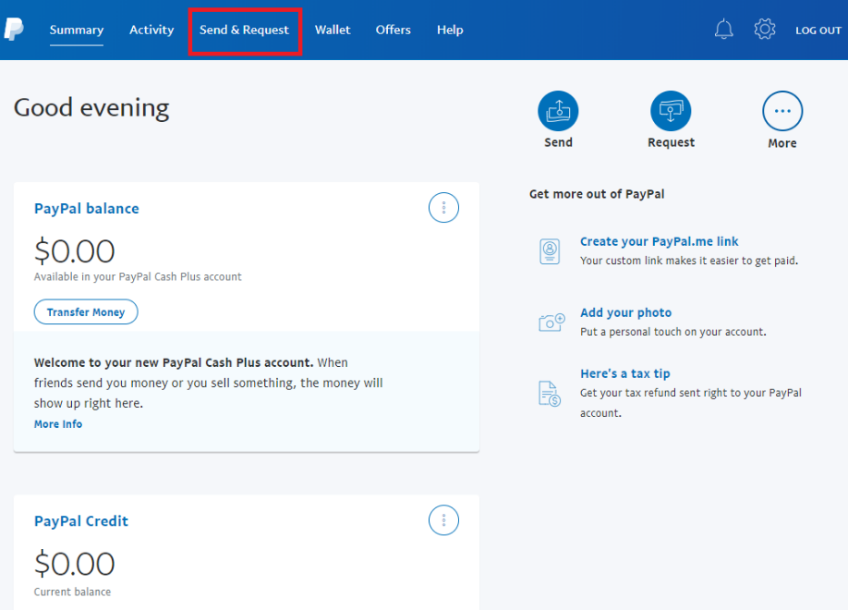

1. Enter ‘zxzheng1@gmail.com’

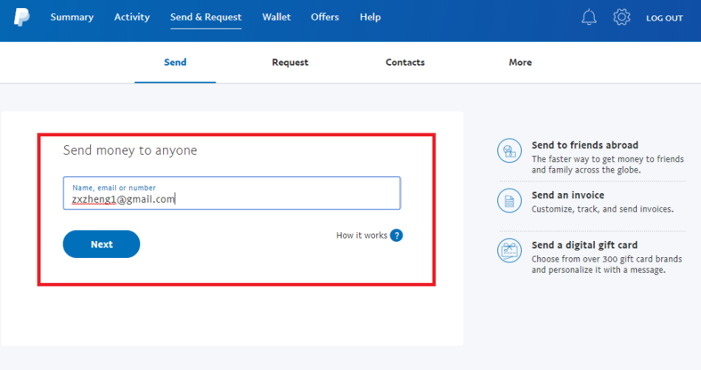

1. Select ‘Paying for an item or service’

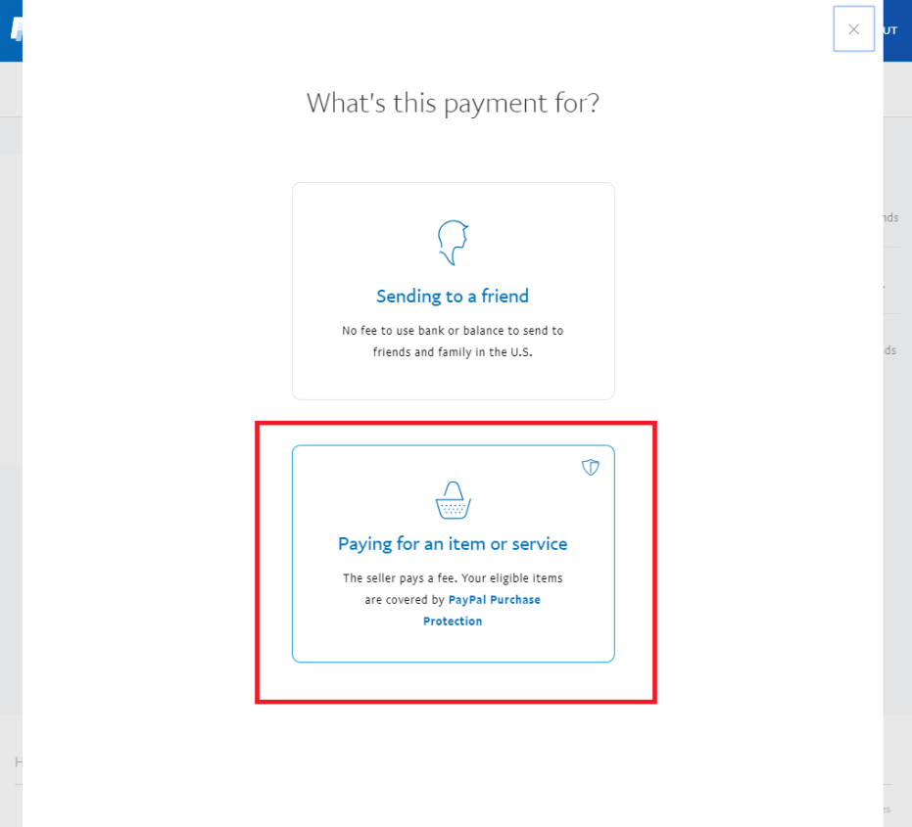

1. Enter the banquet fee:

* **Please include ‘CAFS 2019 Annual Banquet’ and your name in the transaction notes!**
* **Print transaction confirmation and bring it to the Banquet.**

